MISSION

ACTION PLAN
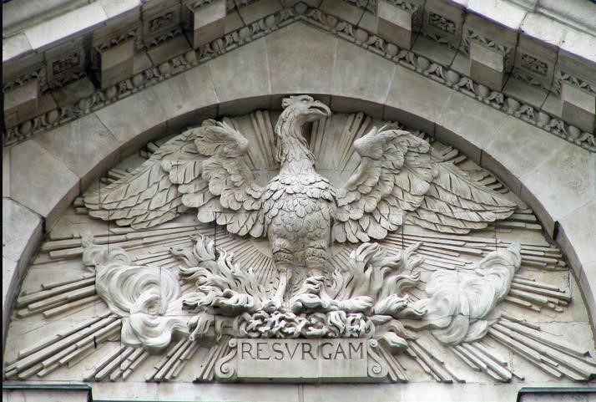
20
2
3
-
20
2
4

RESURGAM

VICAR’S FOREWORD

The origin of this Mission Action Plan 2023-2024 lies in the question which we have asked publicly for some months now- “What is the Holy Spirit leading us to at St John’s Notting Hill in 2023-24? It formed the basis of our PCC-led planning morning at the Sisters of Sion in June. We identified a particular challenge- though all our three electoral rolls have grown - that the “missing element” is families with young children. We address this in our Mission Action Plan.
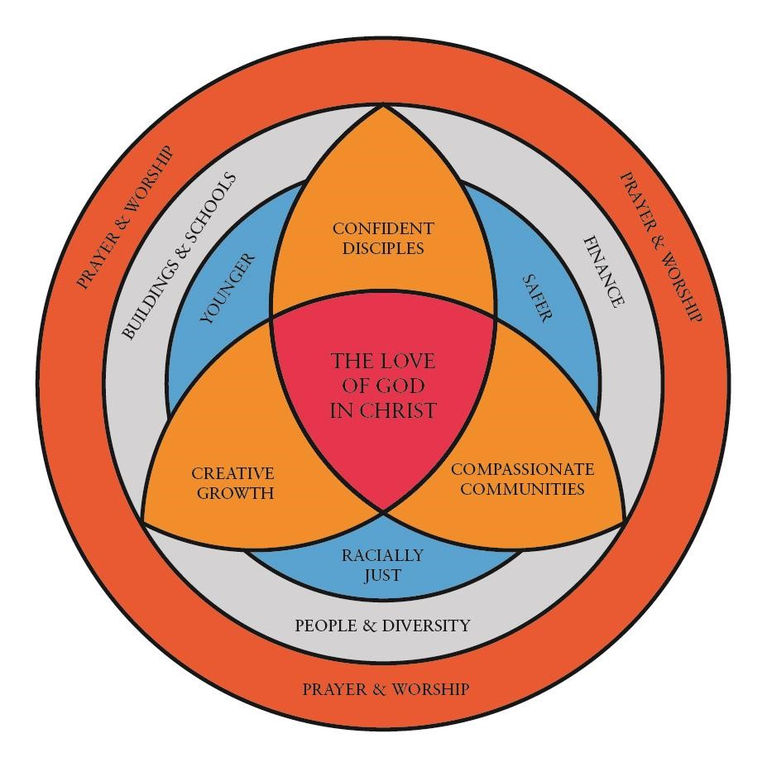
What underlies our resilience is the fact that we are self-consciously a sacramentally open Church. We know that live worship is a huge contributor to spiritual and mental well-being. We are rooted in the life of the Holy Trinity, as the diagram below shows.

This is where we find ourselves in June 2023. As an intercultural Church, we have worked with the Filipino and Persian chaplaincies, as well as with the Ukrainian worshipping group in drawing up our plans. We have been rigorous in our review of our aims and objectives and removed anything which has been on our list we have done nothing about. Our aims and objectives should be both visionary and SMART. With these spiritual and liturgical resources, we feel energised and well equipped for the year ahead. In the widespread consultations we have done, there has been a high degree of convergence in articulating the things on which we need to concentrate in the year ahead – particularly our children’s work and music.
With high hopes for the future, I commend this Mission Action Plan for the year ahead in the certain bedrock of our faith – RESURGAM - “I will rise.”
William Taylor June 2023

Daily Services at St John’s
The Church is open daily from 8.45am until 5.15pm and at times of services

Sunday
8.00 am Holy Communion
10.30 am Sung Eucharist
(Once a month, an All Age format is used)
12.30 pm Tagalog Mass
4.00 pm Farsi Eucharist (once a month)
5.30 pm Evening Prayer
6.30 pm Choral Evensong – once a month.

Monday-Friday
8.45 am Morning Prayer
5.00 pm Evening Prayer

Wednesday

12.00 pm Holy Communion

A healing service, with anointing with oil and the laying on of hands, is held monthly.

Resurrection
We value:

The Anglican balance of Scripture, Tradition, and Reason;

Worship, which is daily, inclusive, varied, and well prepared, using all the resources of the Christian tradition, with a strong focus on the Eucharist;

A church which is open and welcoming in the pastoral offices (baptisms, weddings, and funerals);

The full inclusion of children in the Parish Eucharist, using an All Age format once a month, and, following appropriate preparation, admission of children to Communion before Confirmation, from the age of 7;

The monthly Farsi Eucharist and the Persian Anglican Community of London as a Chaplaincy of the Diocese of London;
Ascension Day 2023
The regular use of visiting preachers and speakers;

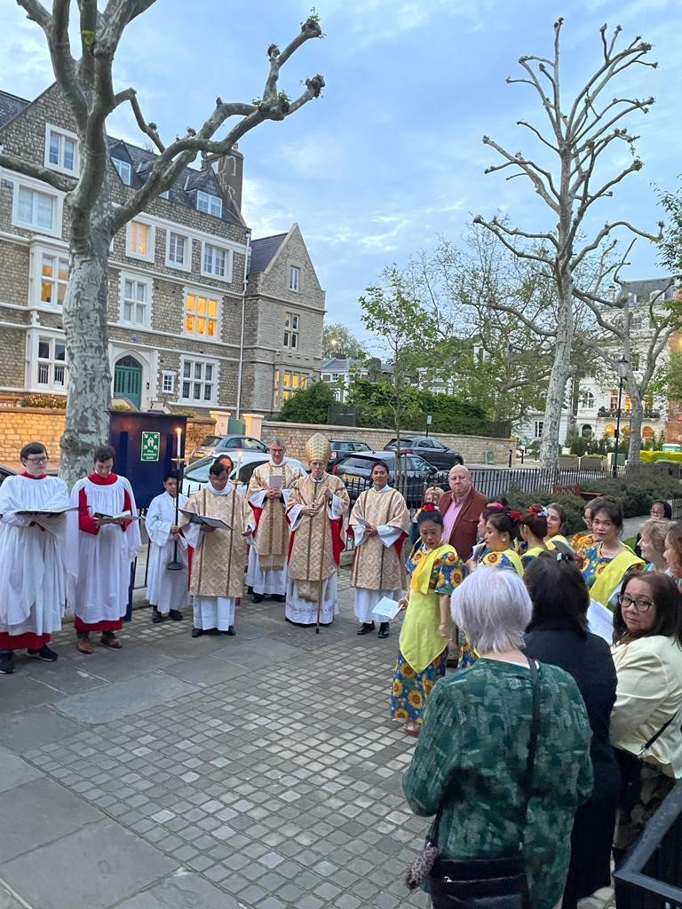
Space for silence, retreats and contemplation;

Creation Time in September and October;

The Parish as a place of training for ministry - lay and ordained, especially for placements for ministers from the persecuted Church;

A well-equipped and trained people of God, congregations, clergy, Eucharistic ministers, servers, intercessors, readers, that regards training, study, and development as the norm;

The term-time programme for Junior Church, with music and art, welcoming children of all ages;

The teaching programme offering a greater understanding of the Christian Faith for all - through courses (including the Rite of Christian Initiation of Adults [RCIA]) events for young people and seekers, house groups, Bible study, and retreats;

The rich variety of Christian backgrounds within our congregations and an ability to articulate confidently the distinctive elements of Christian belief;

The choir that takes a regular part in leading liturgical services, utilising the Choral Scholars;
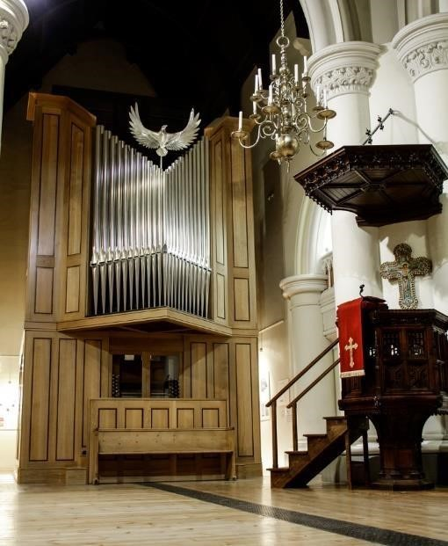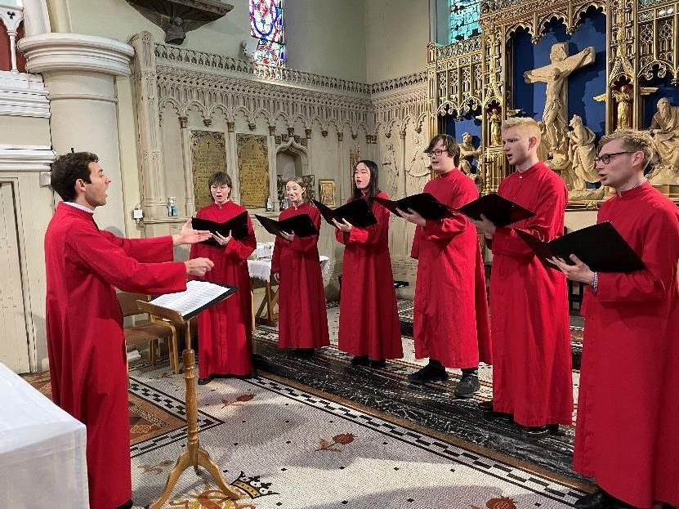

The Sunday evening service in different formats, including monthly Choral Evensong, and as a place for liturgical experimentation;

The Filipino Chaplaincy as a Chaplaincy of the Diocese of London;

The weekly fellowship programme and fund-raising activities of the Filipino Chaplaincy.

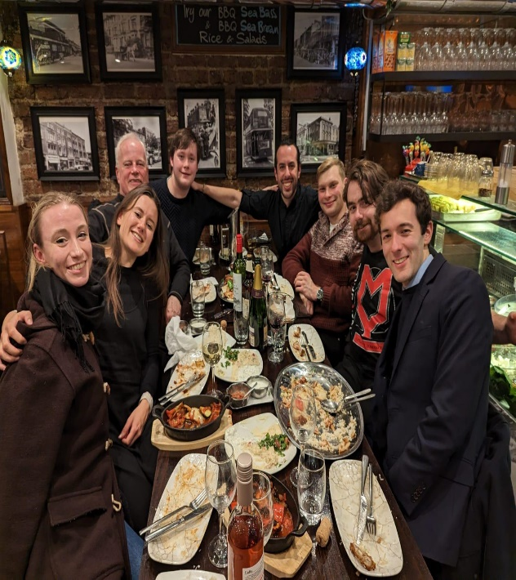
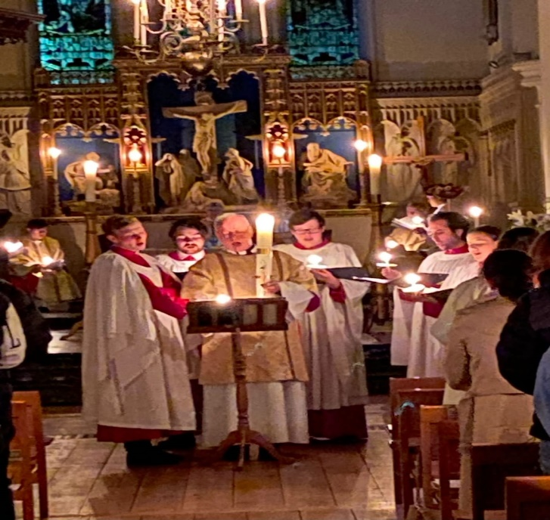

The St John’s Choir Christmas dinner 2022 Easter Vigil 2023

We wish to develop:

- Regular visual displays in the Church of the variety of linguistic and cultural backgrounds of worshippers

- A greater use of social media in different languages advertising our activities.

Flores de Mayo 2023
Iranian food served after the Farsi service
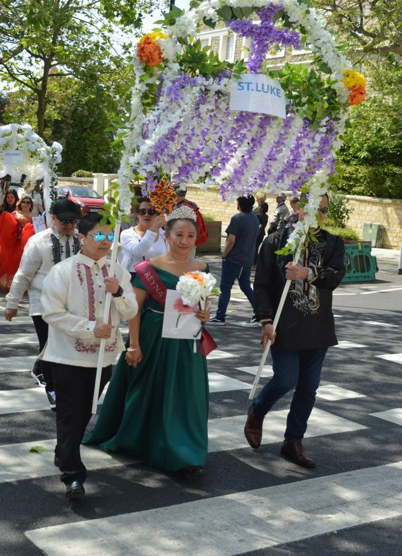
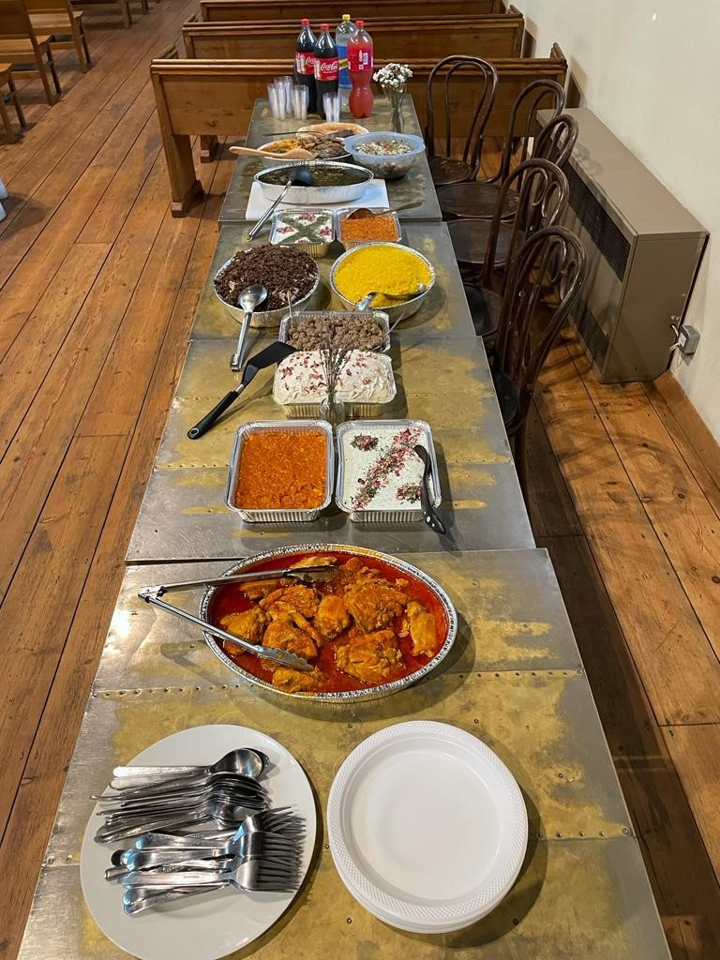
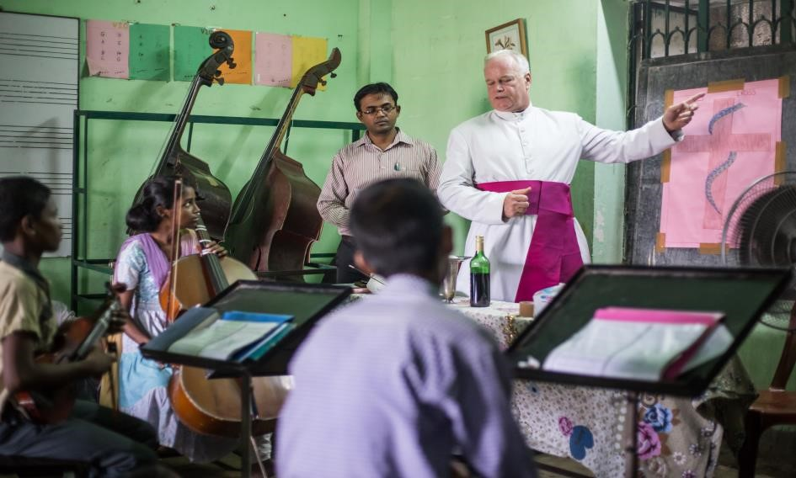

Mathieson Music School - Kolkata

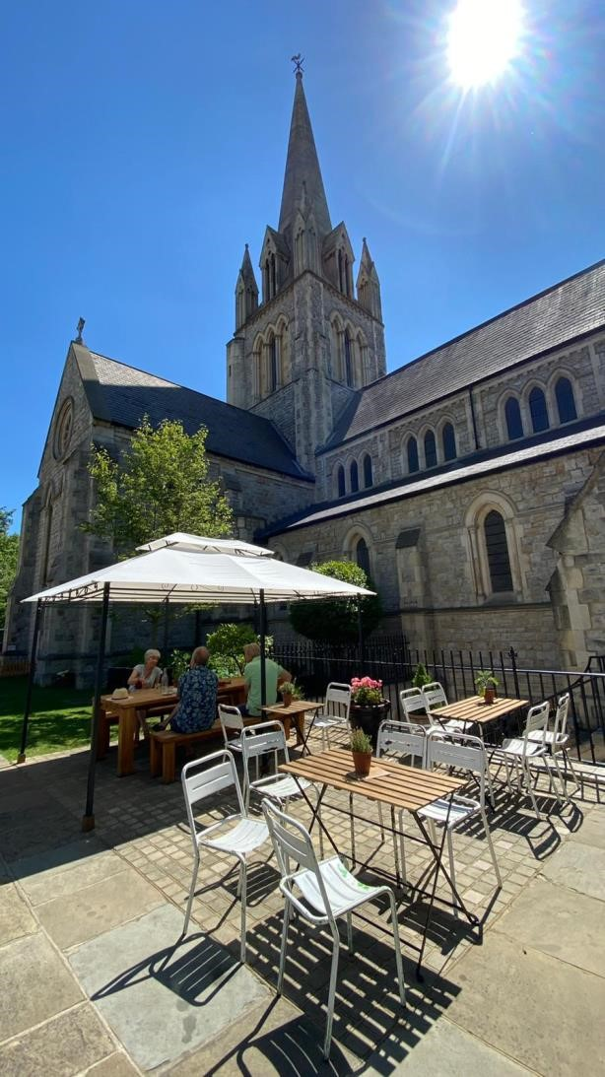
Resilience
We value:

St John’s role as the Parish Church at the centre of the diverse communities of Notting Hill;

Being an active part of the universal church both in
giving and receiving, through the Deanery, Diocese
and Anglican Communion;

Working with our Mission Partners - Mathieson
Music School, Bishop Agostinho Buque
(Mozambique), CMS in South East Asia and the IFI
school in Kalibo, Aklan;

Working not only with other Christian organisations but also with other faith communities;

The commitment and expertise of our Vicar William Taylor with the Orthodox Churches, including his visits, acting as an ambassador, and bringing insight to our worship;

The use and promotion of the monthly fairly traded
Palestinian goods;

The culture of generosity and responsibility that enables us to over contribute towards full payment of the Diocesan Common Fund;

The Café at St John’s, serving refreshments from Monday to Friday;

The better knowledge of each other generated through social events, support groups, and improved communications, using social media and the website;

The groups and individuals from Community Payback working with the Probation Service in the church and grounds;

The permanent exhibition around the organ, showing its history and the development of Notting Hill; History workshops for children and the information leaflets for the public on the history of the Church and its present activities;

The Stewardship Advisory Group meeting regularly to give the theological and spiritual direction to our Stewardship giving which must meet the Diocesan Common Fund without support from other Church activities (lettings, etc);

The Mission Sunday, once a year (Christ the King), focusing on our Mission Partners;

We wish to develop:

- A more proactive welcome to newcomers, inviting them to participate in the life of the Parish including a particular focus on ensuring that connections are maintained with families who have brought children for Baptism;

- The work of Junior Church and All Age Sunday by specific invitations to families to take part in the services;

- Come and sing events open to all.
Anglican Oriental Orthodox International Commission meeting in a Coptic Monastery in Essex
Accompanying the Archbishop of Canterbury in Constantinople

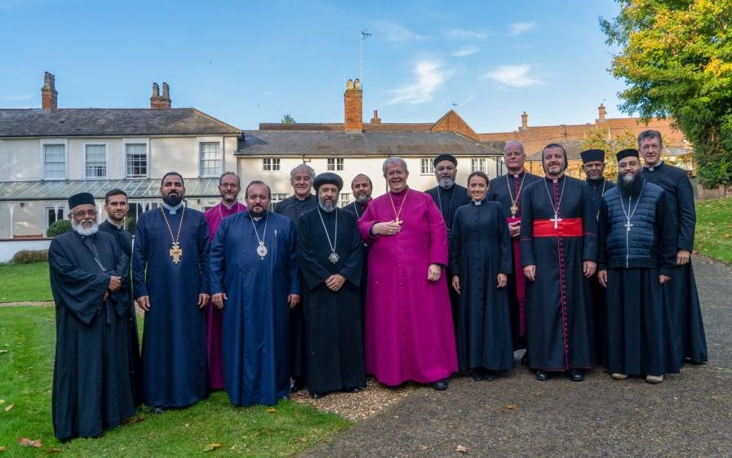
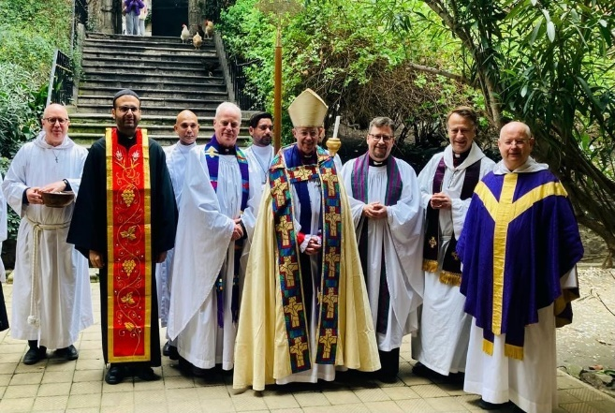
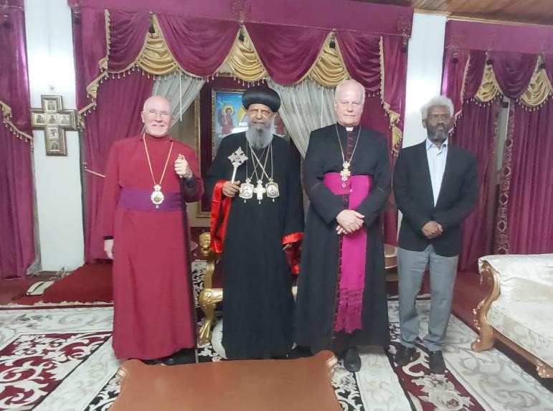
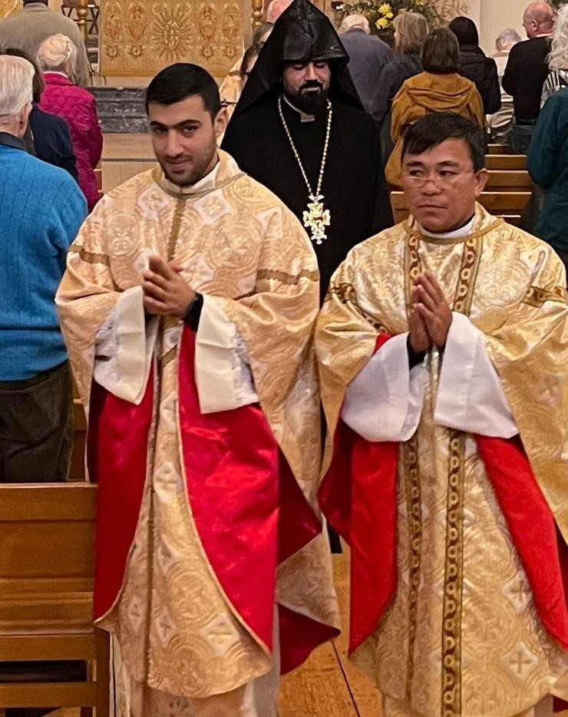
Meeting with the Patriarchate of Ethiopia
A unique ecumenical vocation at St John’s Notting Hill – a Chaldean Catholic priest, an Old Catholic priest and an Armenian preacher

Restoration

We value:

A welcoming, well-maintained building for worship forming the hub of community life;

Acorn nursery, providing childcare for the local community, interwoven with the values of the church;

The use of the grounds for community-based events, such as the Summer Fair, and Notting Hill Carnival;
Wildflower Meadow 2023

Beekeeping Seminar with Prof Cleo Cervancia of the University of the Philippines

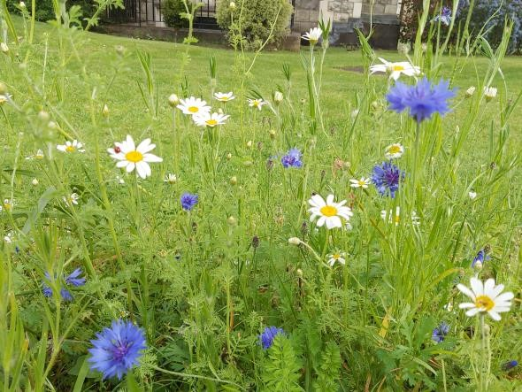
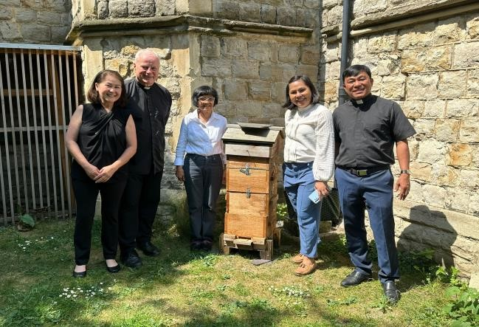

The Bronze award in the Eco-church scheme;

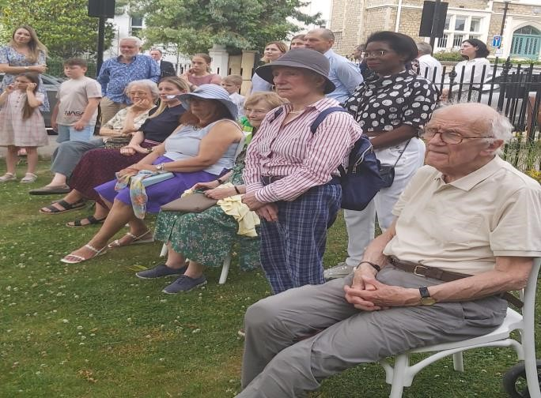
The landscaping of the gardens and the planting of trees, hedges and the new wildflower meadow increasing biodiversity, together with the beehives;
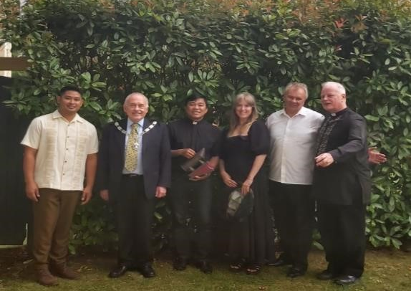
Parishoners and Dignitaries at the Wildflower Meadow Opening 2023

The greater access provided for all users via the disabled entrance at the North Porch;

The role of the Parish & Facilities
Manager and the Maintenance Manager in improving site management, income generation, and security;

The greater access to our grounds through the table and benches on the North side of the church;

The present configuration in the church created by the removal of the crossing platform, restoration of the pulpit, and relocation of the Font and seating further East;

The glass doors at the inner entrances of the North and South Porches, and the grille gates at the outer arch of both Porches;

The chapel for daily prayer and recollection;

The three community rooms (the SPACE) for use by community groups and for income generation;

The Mariupol Collection (part of the Icon Exhibition) leaving St John’s to go to the Ukrainian Cathedral in Central London

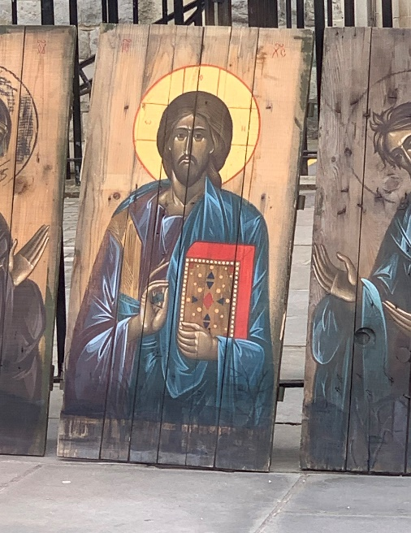
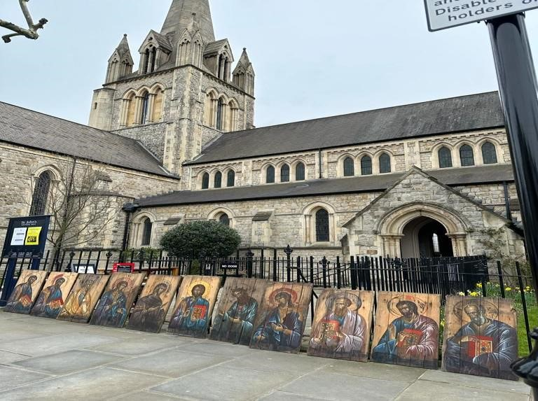

We wish to develop:
- The continuation of the reordering of the interior of the church, especially:
  - Energy efficient heating, lighting, and water systems
  - A sympathetic and appropriate redecoration for the whole of the Church, informed by historic paint analysis, and by the restored Reredos
- A fundraising strategy that supports the implementation of the restoration programme. Appealing for:
  - Public funds
  - Trusts and foundations
  - Charitable donations
- A heritage engagement programme which realises the wider benefits of the restoration, providing a wide range of opportunities for our communities to:
o Develop heritage skills such as church restoration and painting
o Learn about the sacred art of our diverse congregations
o Participate in practical music and visual arts activities
- The continued reduction of our Carbon footprint, working towards a silver award in the Eco-church scheme.

Vegetable planters in the grounds
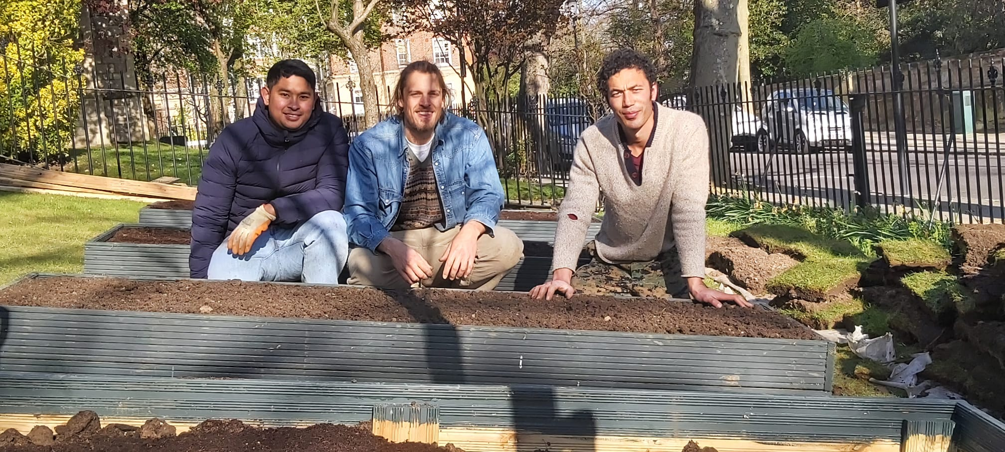

Mission Action Plan 2023-24 Development Plan

 | Resurrection | By whom? | By when?
1. | Regular visual displays in the Church of the variety of linguistic and cultural backgrounds of worshippers | Chaplaincy groups | Beginning  September  2023
2. | A greater use of social media in different languages advertising our activities, by employing a one day a week social media person. | Filipino  Chaplaincy &  Director of  Music | September 2023
 | Resilience
1. | A more proactive welcome to newcomers, inviting them to participate in the life of the Parish including a particular focus on ensuring that connections are maintained with families who have brought children for Baptism; | Vicar and Baptism group | September  2023
2. | The work of Junior Church and All Age Sunday by specific invitations to families to take part in the services; | Junior Church | September 2023
3. | Come and Sing | Director of Music | Autumn 2023
 | Restoration
1. | The continuation of the reordering of the interior of the church, especially:  - Energy efficient heating, lighting, and water systems  - A sympathetic and appropriate redecoration for the whole of the Church, informed by historic paint analysis, and by the restored Reredos | Restoration  Fund Trustees  & Nicole Crockett | Summer 2023
2. | A fundraising strategy that supports the implementation of the restoration programme. Appealing for:  - Public funds  - Trusts and foundations  - Charitable donations | Restoration  Fund Trustees  & Nicole Crockett | Autumn 2023
3. | A heritage engagement programme which realises the wider benefits of the restoration, providing a wide range of opportunities for our communities to:  - Develop heritage skills such as church restoration and painting  - Learn about the sacred art of our diverse congregations  - Participate in practical music and visual arts activities | Lottery funded  programme | From summer 2023
4. | The continued reduction of our Carbon footprint, working towards a silver award in the Eco-church scheme | Energy group | September 2023

The development plan should be SMART
S- Specific
M- Measurable
A- Attainable
R- Relevant
T- Time-based

Strong ecumenical partnerships and generous donors make it possible to respond to need as it arises.

Kolkata Cathedral – preaching April 2023

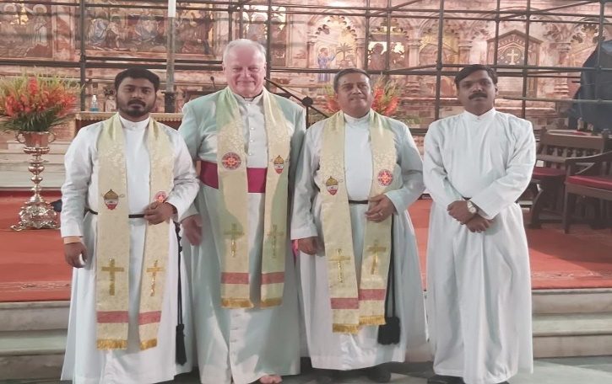

Partnership with the Filipino Chaplaincy –
Provision of 11 new fishing boats after the recent typhoon destruction.

THE SPACE AT ST JOHN'S

C O M E A N D V I E W T H E S P A C E , C R E A T E D F O R C O M M U N I T Y G R O U P S
Bookings accepted by email, telephone or come in person. See office hours below or visit

http://www.stjohnsnottinghill.com/thespace/
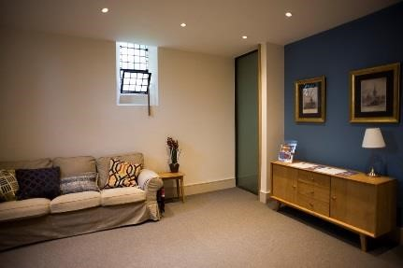
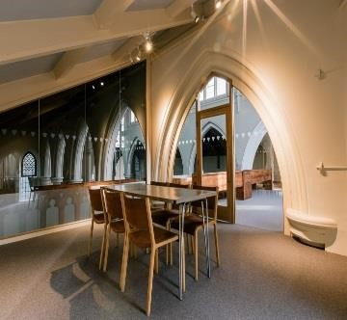
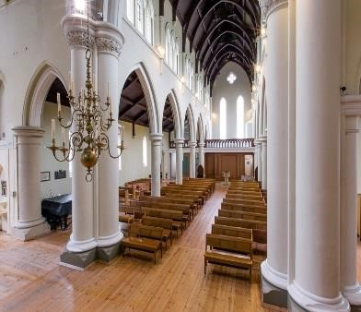
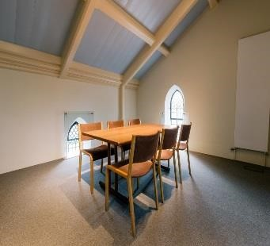

Staff

Vicar: The Rev’d Canon Dr William Taylor, 020 7727 3439, email: vicar@stjohnsnottinghill.com
Filipino Chaplain: The Rev’d Canon Larry Galon, email: larrygalon@ymail.com
Associate Vicar: The Rev’d Alan Trigle email: alantrigle@icloud.com
Licenced Lay Minister: Serena Lancaster email: serena.lancaster@btinternet.com
Parish and Facilities Manager: Amanda Feeney 020 7727 4262, email: officemanager@stjohnsnottinghill.com
Facilities Manager: Mykhaylo Ibelgauptas 07929439704
Director of Music: James Speakman, email: directorofmusic@stjohnsnottinghill.com

Parish Office
St John’s Church, Lansdowne Crescent, W11 2NN
020 7727 4262
e-mail: officemanager@stjohnsnottinghill.com

Officers
Churchwardens
Rosemary Warcup, email: rosemary@thestarcentre.com
Gerard Hargreaves, email: gerard@gerardhargreaves.com

PCC Secretary Paula Lawton
PCC Treasurer
Olakunle Babarinde

Website
www.stjohnsnottinghill.com

